In Angular, routing is the mechanism that allows navigation between different views or components within an application. It involves configuring routes to associate URLs with corresponding components, enabling the application to display specific content based on the URL path. This is typically managed using the Angular Router module, which handles the navigation and URL parsing.

**Command to Generate :**

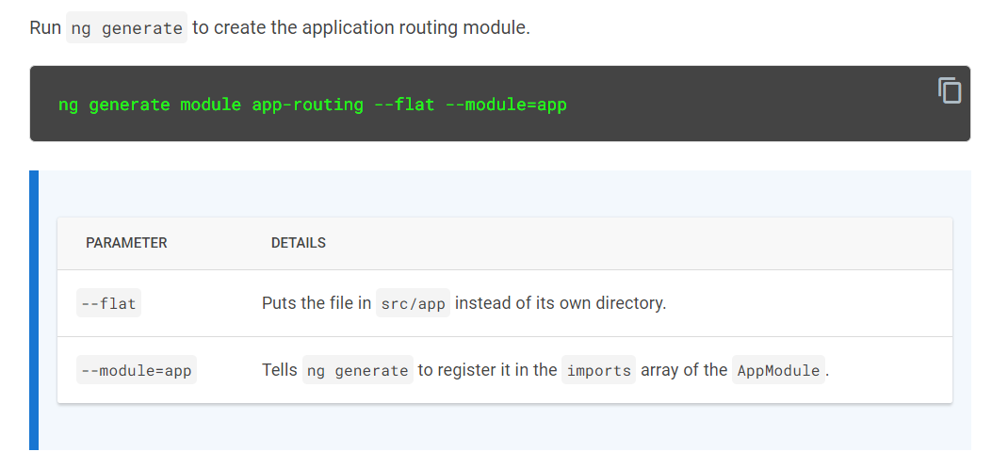

|  |  |
| --- | --- |
| The file that ng generate creates looks like this: |  |

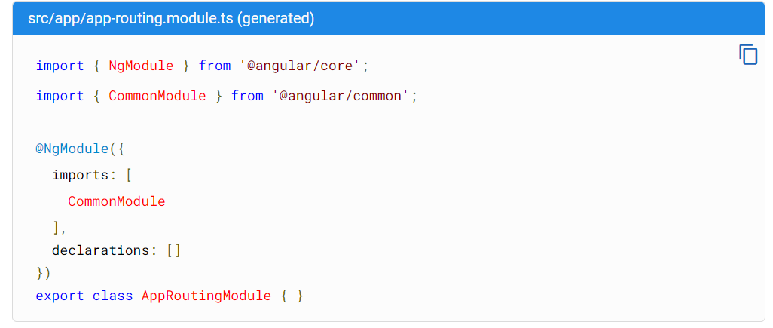

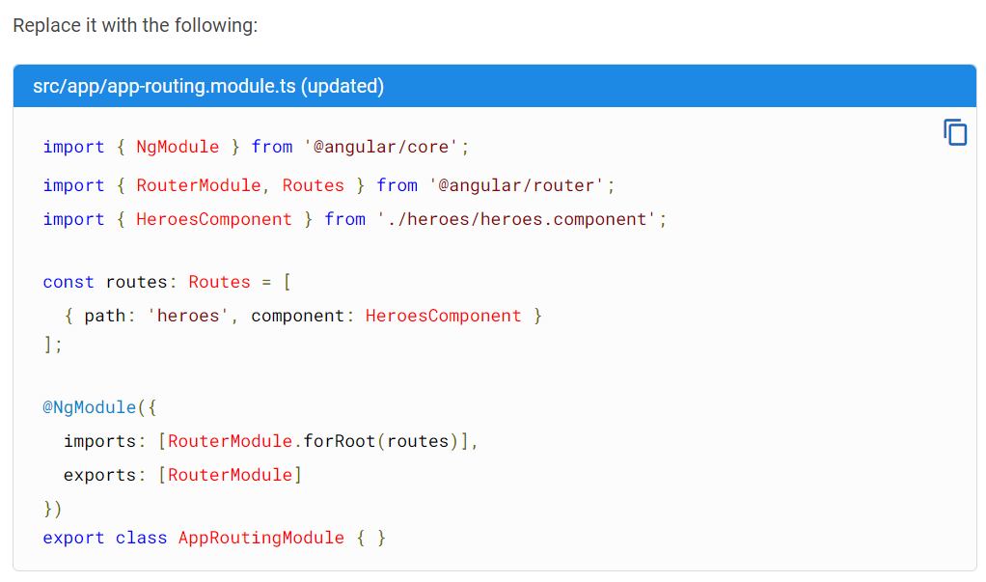

Routes tell the Router which view to display when a user clicks a link or pastes a URL into the browser address bar.

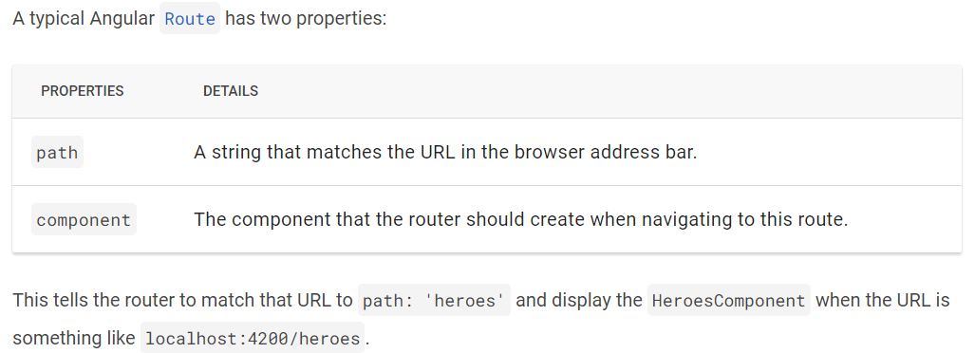

We add RouterModule.forRoot() in the imports array of an Angular module to configure the router at the application's root level. This method initializes the router with a set of routes, enabling navigation and linking between different components throughout the application.

AppRoutingModule exports [RouterModule](https://angular.io/api/router/RouterModule) to be available throughout the application.

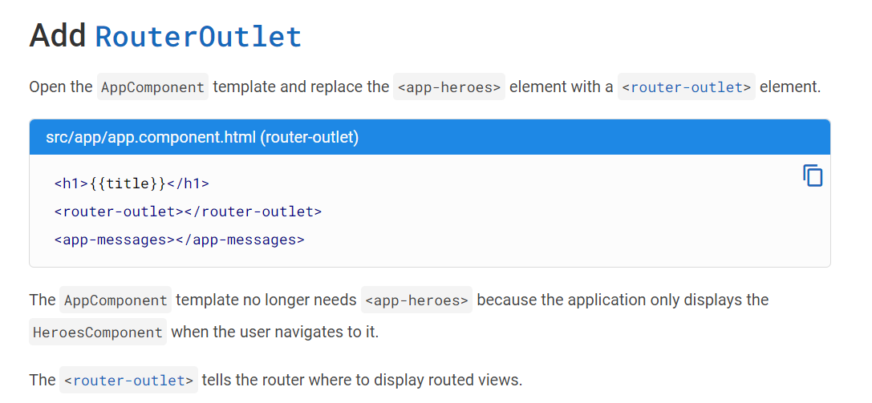

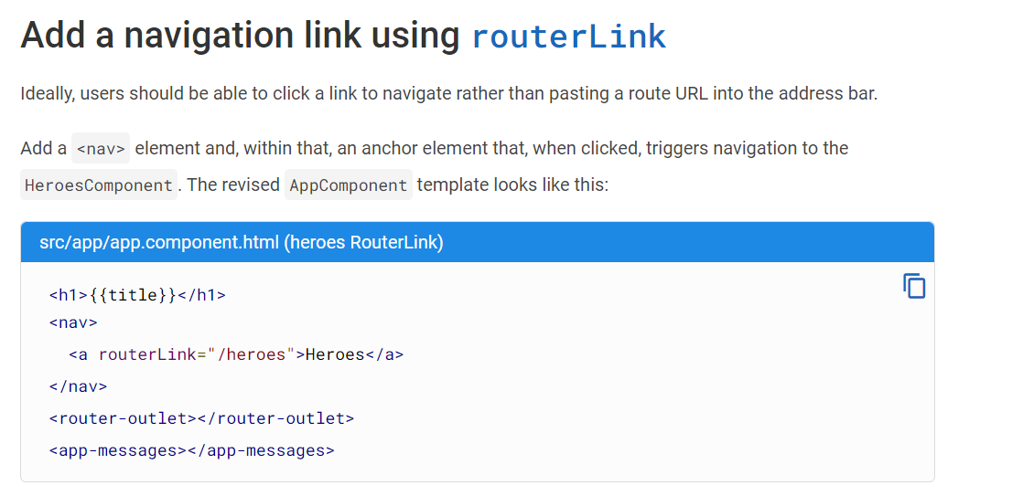

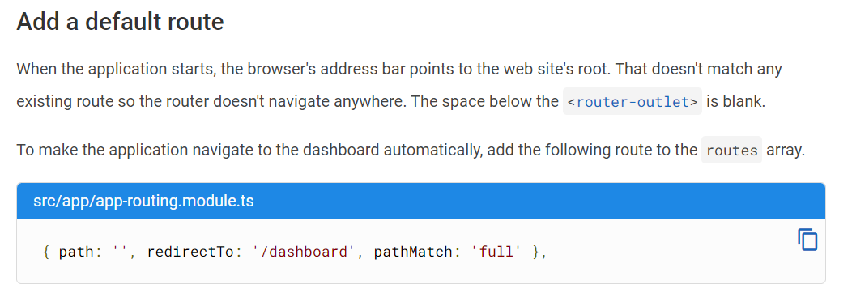

Add a *hero detail* route

A URL like ~/detail/11 would be a good URL for navigating to the *Hero Detail* view of the hero whose id is 11.

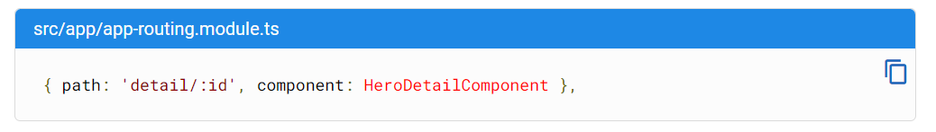

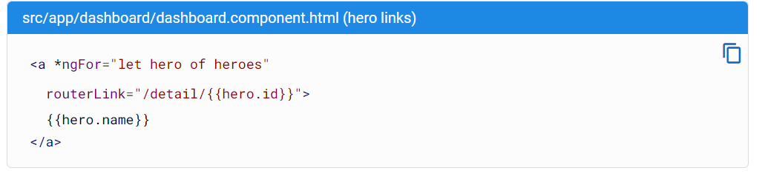

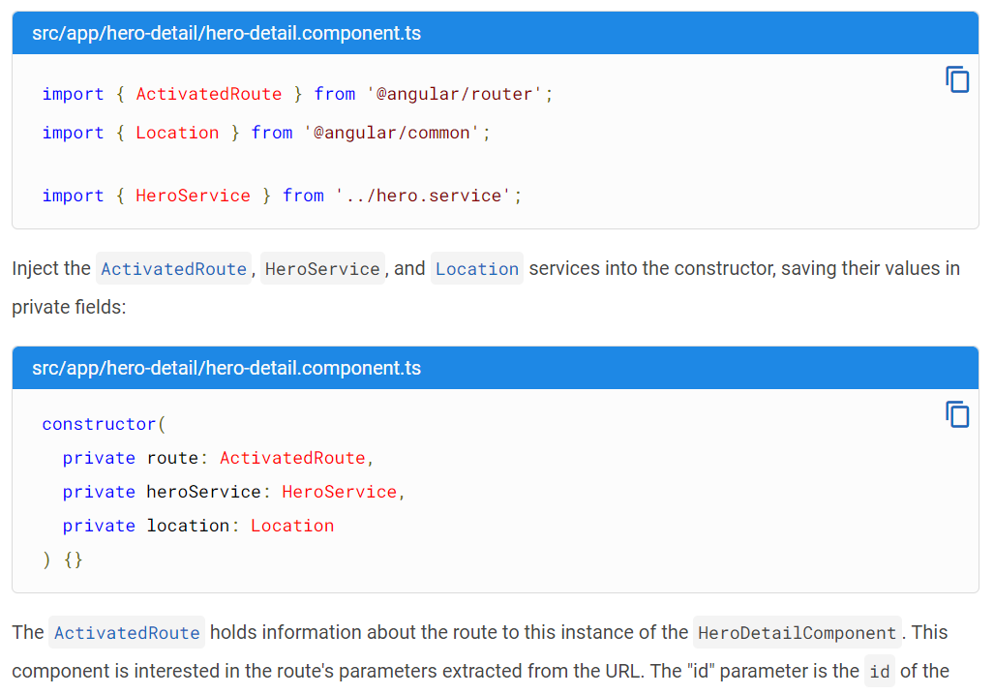

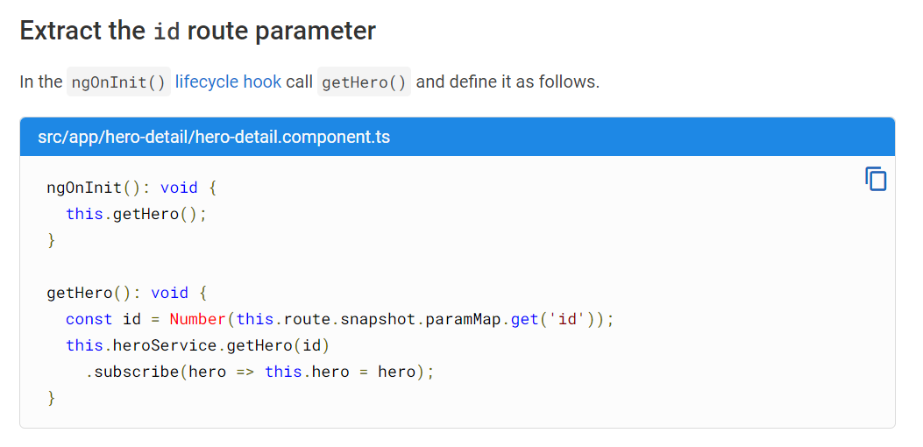

**Child Component Routing :**

To add child component navigation in Angular routes, you can define child routes within a parent route using the children property. Here’s a simple example to demonstrate this:

